**CO-HOOTS**

CO-WORKING SPACES



PROJECT REPORT



Submitted By: Aasavari Kaley

Ajay Deshmukh

Gnanitha Meka

Rujuta Tamhankar

**INDEX**

Problem Statement 1

Project Description 1

Gantt Chart 2

Business Need

Business Requirement

Business Value

Special Constraints

Scope of System

Functional Requirements

Non-Functional Requirements

Use Cases

Data Flow Diagrams

Data Dictionary

Program Structure Chart

UI Screenshots

Future Scope

Conclusion

References

Problem Statement

Coworking space provides an ideal work environment for entrepreneurs, start-ups, and freelancers. A self-employed individual might consider using a  [coworking space](https://www.theworkloft.com/coworking-space-%E0%B8%81%E0%B8%A3%E0%B8%B8%E0%B8%87%E0%B9%80%E0%B8%97%E0%B8%9E/). Alternatively, a company that employs remote workers, could provide them with a professional environment. Either way, coworking spaces give people ample and potentially valuable networking opportunities. People from different organizations or even different industries can mingle and [share tips and ideas with one another](https://theworkloft.com/blog/10-shared-office-space-etiquette-rules-coworking-infographic). One does not even have to sign a lease to use one. Plus, given rising real estate prices, to buy or rent an office of comparable value might be prohibitively expensive, and that’s not even factoring in the furniture or the pieces of equipment a coworking spaces contains and offers. Co-working spaces could take the money that a coworking space would save you and invest it in other ways. This approach would improve business.In the end, how many professional services are capable of reducing costs while lifting employee morale and productivity at the same time? co-working spaces is definitely one of them.

Project Description

Coworking spaces are essentially shared workspaces. We offer affordable office space, at six different geographical locations, for those looking to escape the isolation of a home office or coffee shops. These shared workspaces offer a suite of office-like amenities such as hot-desks, private meeting rooms, kitchens, coffee and more. These spaces provide more than a nice desk and chair to sit and work; each of the workspaces has a culture of success — which is exactly what you need to help your business thrive. These shared spaces would allow true freedom and mobility. The culture would be conducive to truly organic collaboration and conversations that could be struck up. In one way this is the value of coworking spaces. We allow for innovation by allowing different people with unique skills and talents to connect and collaborate. Another advantage is the fact that culture is shaped out of the concept of freedom and flexibility. The genesis of coworking spaces is based on serving the needs of small organizations and freelancers to connect. Additionally, coworking spaces are effective for and also serve a purpose for larger organizations looking to innovate.

Gantt Chart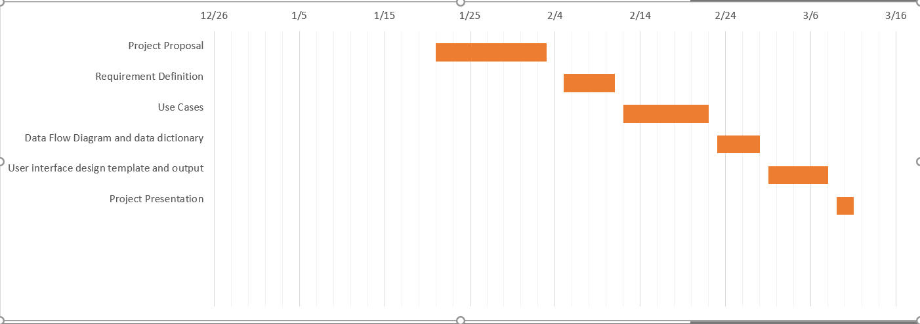

Business Need

A lot of freelancers and startup have been coming out with brilliant project ideas but lack the place and facilities to work on their projects. The project of Co-working space has been initiated to develop a system which will provide freelancers and startups with the option of renting an office space and supporting facilities to work seamlessly on their projects. This system will help users rent office space on a daily, monthly or yearly basis with the option of renting the facilities present at the office space.

*Freelancers****:*** Co-working spaces create the best of both worlds for freelancers: The flexibility of choosing your own hours and schedule without isolation. These shared spaces are thus great for freelancers. A feeling of community is created for those that would otherwise be forced to work alone at home or a coffee shop.

*Start-Ups* : Start-ups appreciate the flexibility of coworking spaces. Coworking spaces don’t come with the high costs and commitments of a traditional office lease. This system will provide the chance for small teams to interact with others in the space. These spaces also may even help entrepreneurs find a co-founder for their start-up by connecting the right people at the right time.

Business Requirements

Using the coworking spaces, offices can be rented to the start-ups, freelancers, entrepreneurs on a daily, monthly or yearly basis. The office space for a client would be customized with other amenities like network facilities, infrastructure facilities, and transport facilities. The nearest location would be offered to the customers based on their needs. The system should incorporate the below requirements to support the business.

1. Create User profile - A customer who wants to rent a coworking space should be able to register on the company website. Once the profile is created, they can proceed with the next steps.
2. Select office sites based on location and size - Users will enter a preferred location of the office from available options and system will display the details of the chosen office site.

User will select the size of the office and rental details. System will display the estimated cost based on the selection.

1. Offer office related services- Once the coworking space is selected,the system should display the default services provided like electricity, Air conditioning, common cafeteria, restrooms. Then the user will be allowed to choose optional services like internet, computers, wifi, and printers. The additional charges for each service would be displayed and added in the final bill as soon as the user selects additional services.
2. Provide Transportation service - The pickup and drop services would be provided to the employees of each registered organization at additional charges. Total charges will be calculated based on a number of employees in the organization. Transportation charge will be fixed per employee irrespective of the distance.
3. Process the online payment for customer- Once the coworking space is customized with additional services, a final quote will be generated and shown on the screen. The user will be given an online payment option to facilitate the payment via credit card or net banking.
4. Assign and manage user rewards - The system will store the booking history in the user profiles. Monthly and yearly subscriptions would be offered reward points. These reward points will allow the customers to redeem the points in their subsequent bookings.
5. Manage online platform and datastores: The system is responsible for updating and maintaining the website and datastores on the directions of the system administrator.

Business Value

It is expected that the co-working space will bring in sales and revenue by implementing the above-mentioned system. The major source of revenue comes from the reserving the space through the company website. We can expect additional revenue from the amenities(computers, wifi, printers) provided. We can expect to gain a new revenue stream from transportation services. The revenue can be increased by the rewards system introduced.

Conservative estimates of tangible value to the company include the following:

* $250,000 per month in sales from space reservations.
* $20,000 per month in sales from amenities.
* $10,000 per month in sales from transportation services.

Conservative estimates of intangible value to the company can include advertisement and publicity. The brand value can be increased through this, which in turn helps in increasing the revenue of the company.

Special Issues and constraints:

The system is not available offline. Without active internet connection, users will not be able to reserve any office spaces or avail the transportation service provided.

Scope of the System:

The scope of this system is to have an efficient system which will help the start-ups and freelancers who want to rent the office space on daily/monthly/annual basis. The project will take around 2 years to develop completely as our system integrates the offices from 6 different locations. The entire system is targeted to be developed in 16 months and last 8 months will be dedicated to testing which will help us to generate a feasible system.

Functional Requirements:

Process Oriented:

1. Create User profile:

1.1 System should allow a new user to sign up using email id.

1.2 User should be able to set the username and password at the time of signing up.

1.3 After signing up, the system should send account authentication link on the registered email id.

1.4 The existing users should be able to log in into the system using username and password

2. Select office sites based on location and size:

2.1 The system must provide users with a list of available office locations to choose from.

2.2 The system must display the pictures and description of the office site chosen.

2.3 The system should ask the user to select the office size and rental details like startdate, and rent option as daily, monthly and annual. System should provide two separate options for freelancer and start-up to proceed further.

2.4 The system must display the chosen office details like office size, estimated rental charges and rental duration.

3. Offer office related services

3.1 After selecting the office site based on the location and size, system should display the default office services provided.

3.2 The system should display the list of optional services like desktop/laptop, internet, and printer.

3.3 The system should display the cost of optional services for each rent option (daily,monthly and annual).

3.4 Bases on the optional services selected and corresponding charges, additional costs must be added to the rental charges.

4. Provide Transportation service:

4.1 The system must provide an option to use transportation services and display the charges for daily, monthly and annual options.

4.2 The System should allow to choose the number of employees making use of transportation services.

4.3 The system should display the list of bus stations for the transportation service.

4.4 The system should calculate and display the total charges incurred.

5. Process the online payment for customer:

5.1 After selecting the rent option and additional services, the system should display the order summary and ask the user to check out.

5.2 After checking out, the user should be navigated to the payment screen. Payment screen should display the total amount and payment details.

5.3 System should allow to redeem the reward points available with the customer’s account.

5.4 Once the user confirms the payment, the system should display the payment status.

6. Assign and Manage User rewards :

6.1 The system should automatically assign 10% of monthly rent, reward points to users.

6.2 The system should automatically assign 20% of yearly rent, reward points to users.

6.3 The system should allow users to redeem the reward points in their subsequent reservation or booking.

7. Manage Online platform and datastores:

7.1 The system should update the datastores with new entries of office location and services provided when needed by the system administrator.

7.2 The system should notify the system administrator about the payments made and corresponding details.

Information-Oriented:

1. The system will store the user’s username and password.
2. The system must store a user’s booking history.
3. The system should store the default services offered.
4. The system must store the rent option, and optional services like internet, computers, WiFi, and printers.
5. The system must store the transportation opted by the customers.
6. The system must store the reward points of monthly and yearly subscribers.
7. The system must store office locations.

Non Functional Requirements:

Operational:

1. The system should support MYSQL database to store the bookings, co-working space locations and other services provided.
2. The system should be compatible with Windows 7, 8, 10 and Mac operating system.
3. The system access control should be remote manageable since the space owner is not always on-site.
4. Website should be compatible with hand-held devices/ mobile browsers.
5. A separate backup server should be present on different geographical location as backup to the primary server.

Performance:

1. The system needs to allow 24/7 access.
2. The website should be accessible throughout the year except for the maintenance period of the website, which takes place once in 3 months.
3. The system should be able to update changes within 7 seconds of every booking.
4. The system should be able to process the transactions typically within 5 seconds.
5. The system should be able to store the data at least upto 1TB.

Security:

1. Allocate unique credentials and a password to each user for Wi-Fi connection to protect customer’s data from being hacked.
2. The system should include spyware and web protection to keep the system safe from virus attacks.
3. Only the system administrator has access to the system to add or edit the services provided.

Cultural and Political:

1. The co-working space should comply with state and federal laws, regarding the working and location acquisition.
2. The website must be available in multiple languages.
3. The user details should be protected under ‘American Customer Information Protection Act’.

Use Cases :

The use cases will help in capturing the requirements of a system. Each business requirement will translate to a use case. The sequential steps in the use case will derived from the process requirements of the system. This helps us determine the interaction between the user and system. We have seven major use cases for the Co-Hoots.

|  |  |  |  |
| --- | --- | --- | --- |
| Use Case Name: Create User Profile | ID: UC-1 | Priority: High | |
| Actor : User | | | |
| Description: The use case describes a new user registration and returning user login into the system for reserving office spaces. | | | |
| Trigger: Customer wants to reserve office space.  Type: External | | | |
| Preconditions: 1. The website is available and running  2. The user database is up-to-date and online  3. Updated registered user details | | | |
| Normal Course:     1. User logs into the system using the requested credentials. 2. User signs up into the system using the requested credentials. 3. On signing up, system sends the authentication link on the registered email ID 4. The system verifies the entered details 5. If the entered details are correct:    1. The system displays the user account page   6. If the entered details are incorrect:  a. The system displays an error message and displays the user login page again.  7. If the user forgets the username or password:  a. The systems prompt username/message  Recovery options. | | Information for steps:  Username, Password  First name, last name, Email, username, password  Authentication link  Login credentials  User account page  Error notification  Recovery message | |
| Post-conditions: The user is logged in the system to book or reserve. | | | |
| Summary Input | Source | Output | Destination |
| Username, passwords  First name, last name, Email, username, passwords  Authentication link  Login credentials | User  User  User  User | User account page  Error notification  Recovery message | User database  User  User |

|  |  |  |  |
| --- | --- | --- | --- |
| Use Case Name: Select office sites based on location and size. | ID: UC-2 | Priority: High | |
| Actor : User | | | |
| Description: The user will select the office site based on the location and the size, system will display the description and the details of the chosen office site. | | | |
| Trigger: The user selects the location and size of the office site from the available option  Type: External | | | |
| Preconditions: User is logged into the system | | | |
| Normal Course :  1.0 Sort office sites based on the location and size   1. The user selects the preferred location from the available drop down menu. 2. The system retrieves and displays the pictures, description, and the map of the chosen office site. (Alternative course 1.1) 3. The user selects the number of room(for startup) or number of desk (freelancer) from the available drop down menu. 4. The system retrieves the cost based on the location and size selected. 5. The system displays this cost to the user. 6. The system asks for confirmation to rent this space. 7. The system will store the details of the rent transaction in the office rent transaction datastore | | Information for steps:  Preferred location  Details of the chosen location      Preferred size  Cost for rented space  Cost details  User confirmation  Office rent details | |
| Alternate Course:  1.1 The office site is already reserved (branch at step 3)  1. The system asks the user if he wants to modify the selection or to cancel the order.  2a. The user wants to modify the search.  3a. The system displays the pictures, description, and the map of the chosen office site.  4a. The system displays cost and asks for user confirmation.  2b. The user does not want to proceed further  3b. The system terminates the use case. | | User change authentication  New Location and size  Details of the chosen location  User confirmation  Cancellation | |
| Postconditions:   1. The preferred office site is finalized. 2. Rent Office rent transaction details database is updated. | | | |
| Summary Input | Source | Output | Destination |
| Preferred location  Details of the chosen location  Preferred size  User confirmation  Cost for rented space  User change authentication  New Location and size  Cancellation | User  Office and services details datastore  User  User  Office and services details datastore  User  User  User | Office rent details  Cost details | Rent transaction datastore  User |

|  |  |  |  |
| --- | --- | --- | --- |
| Use Case Name: Book Office services | ID: UC-3 | Priority: High | |
| Actor : User | | | |
| Description: The user is prompted to select the services desired for the office space rented. | | | |
| Trigger: User finalizes the office location and proceeds.  Type: External | | | |
| Preconditions:   1. The preferred office site is finalized. 2. The co-working space database has a cardinality which relates the Office Location Datastore with the Services provided Datastore. 3. Rent transaction details datastore is up to date. | | | |
| Normal Course:  1.0 Provide the user with office specific services for selection   1. The system retrieves the services provided at that specific office location 2. Display the list of services available services at that specific office location 3. User selects the services desired 4. The system displays the charges on the basis of the services selected. 5. The system asks for confirmation to book the services. 6. The system will store the details of the transaction in the transaction datastore. | | Information for steps:  Retrieve services provided  Display Services provided  Select Services  Display cost  User confirmation  Service details | |
| Post Conditions: The office services are booked by the user.  User services datastore is updated | | | |
| Summary Input | Source | Output | Destination |
| Retrieve services provided  Select Services  User confirmation | Office and services details datastore  User  User | Display Services provided  Display cost  Service details | User  User  User Services datastore |

|  |  |  |  |
| --- | --- | --- | --- |
| Use Case Name: Book transportation services | ID: UC-4 | Priority: High | |
| Actor : User | | | |
| Description: The user selects the preferred location for pick up from the list of bus stations if he chooses to opt for the location service | | | |
| Trigger: User finalizes desired services and proceeds further.  Type: External | | | |
| Preconditions: The co-working space database has a cardinality which relates the Office Location Datastore with the Transportation Services provided Datastore.  User services datastore is up to date. | | | |
| Normal Course:  1.0 Provide the user with the option of booking transportation services.   1. The user opts for transportation services. 2. The system retrieves the list of bus stations. 3. Display the list of bus stations to the user. 4. User selects the number of employees using transportation services. 5. The system displays the charges for the transportation services. 6. The system asks for confirmation to book the transportation services. 7. The system will store the details of the transaction in the transportation service transaction datastore. | | Information for steps:  User selection  List of bus station  Display list  Number of employees  Display charges  Station charge confirmation  Transportation service details | |
| Post conditions: The transportation services are booked by the user. | | | |
| Summary Input | Source | Output | Destination |
| User selection  List of bus station  Number of employees  Station charge confirmation | User  Office and services details datastore  User  User | Display list  Display charges  Transportation service details | User  User  User Transportation Datastore |

|  |  |  |  |
| --- | --- | --- | --- |
| Use Case Name: Process the online payment for customer | ID: UC-5 | Priority: High | |
| Actor : User | | | |
| Description: The user confirms the order and proceeds with the payment. | | | |
| Trigger: User selects the rent option and the additional services and confirms the order.  Type: External | | | |
| Preconditions:   1. The user selects the desired location of the co-working space, time period, transportation services and other desired services. 2. The cart contains the order placed by the customer. | | | |
| Normal Course:  1.0 The transaction summary is displayed.  1. The system retrieves the data from the rent transaction datastore, user services transaction datastore and user transportation datastore and summarises the transaction details.  2. The system displays a message asking if the user wants to confirm the order and proceed to pay. (Branch to 1.1)  3. The user selects the payment option.  4. The user enters debit/credit card details.  5. Order confirmed and the database updated with the user reservation details.  6. Database updated with user payment details for future transactions.  7. Order confirmation notification sent to the user email-id. | | Information for steps:  Transaction summary page.  Order confirmation page.  Payment page.  Credit card details.  Payment transaction details  User payment details  Confirmation email. | |
| Alternate course:  1.1 The system provides the user with the option of redeeming reward points(Branch at step 2)  1. The user can select if he wants to redeem reward points or save it for the next reservation.  1a. The user chooses to redeem.  1b. New transaction summary with the applicable discount is displayed.  2a. The user chooses not to redeem and keep the reward points intact.  2b. The system continues with the previous, unchanged transaction summary. | | Redeem points  Payment page  Cancellation  Payment page | |
| Exceptions:  1.2 If the user enters wrong debit/credit card details.  a. The system notifies the user of the incorrect card information and redirects to the same page till the correct information is entered. | | | |
|
| Post conditions:  1.Payment process completed successfully.  2.User occupies the reserved space. | | | |
| Summary Input | Source | Output | Destination |
| Transaction summary page  Order confirmation page  Payment page  Credit card details  Redeem points  Cancellation | System  System  User  User  User  User | Payment transaction details  User payment details  Confirmation email | Payment transaction datastore  User datastore  User |

|  |  |  |  |
| --- | --- | --- | --- |
| Use Case Name:Assign and Manage User rewards | ID: UC-6 | Priority: High | |
| Actor : User | | | |
| Description: The user is assigned user rewards based on the amount of money spent collectively on the rented space and services selected. | | | |
| Trigger: User successfully completes payment.  Type: External | | | |
| Preconditions: User has completed the payment process successfully. | | | |
| Normal Course:  1.0 The user rewards are calculated on the basis of the total cost of payment.   1. The payment details for the customer are retrieved from the payment datastore. 2. The system calculates the user reward points which is 10% of the payment made. 3. The system stores these points in the user rewards datastore. 4. The system displays the user reward points to the user. | | Information for steps:  Payment details  Reward calculation  User reward details  Display Reward points | |
| Post conditions: User rewards are assigned to the user and can be used for further payments. | | | |
| Summary Input | Source | Output | Destination |
| Payment details  Reward calculation | Payment detail datastore  Payment detail datastore | User reward details  Display Reward points | Reward details datastore  User |

|  |  |  |  |
| --- | --- | --- | --- |
| Use Case Name: Manage online platform | ID: UC-7 | Priority: High | |
| Actor : System Administrator | | | |
| Description: The system administrator will maintain and update the online platform details. | | | |
| Trigger: Office location details need to be updated.  Type: External | | | |
| Preconditions: The datastore has the existing details of the office location and other services | | | |
| Normal Course:  1.0 Maintain and update the online platform  1. The system authenticates the user.  2. The system administrator updates the system with new details of office locations and other services.  3. The system displays a message asking the user to confirm the updated details.  4. The office and services details datastore is updated.  5. The system notifies the administrator of the new user once the payment is made.  6. The payment transaction datastore is updated. | | Information for steps:  User login details  New location and services details  Updation confirmation page  New office location and services details  New user payment details  New payment details | |
| Post conditions:   1. The datastores are updated with office location details and new services offered. 2. The system administrator will be notified of the new payments completed. | | | |
| Summary Input | Source | Output | Destination |
| User login details  New location and service details | System  System | Updation confirmation page  New office location and services details  New user payment details  New payment details | System administrator  Office and service details datastore  System administrator    Payment transaction datastore |

DATA FLOW DIAGRAMS:

CONTEXT DIAGRAM:

The first DFD in every business process model, whether a manual system or a computerized system, is the context diagram. As the name suggests, the context diagram shows the entire system in context with its environment. All process models have one context diagram.The context diagram shows the overall business process as just one process(i.e., the system itself) and shows the data flows to and from external entities. In Co-Hoots we have two external entities one is User and the other is System Administer. Our system will interact with external system to retrieve and confirm the payment information.

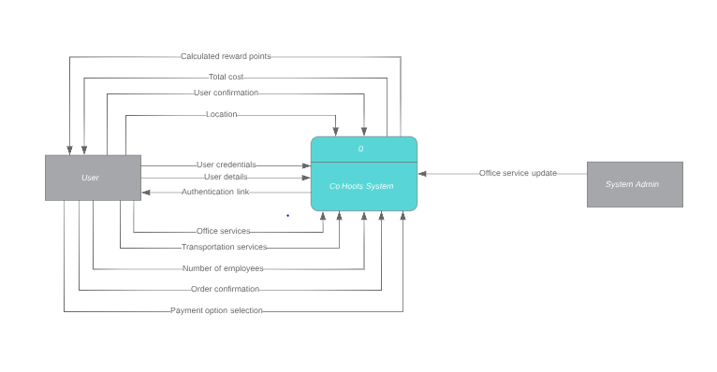LEVEL 0 DFD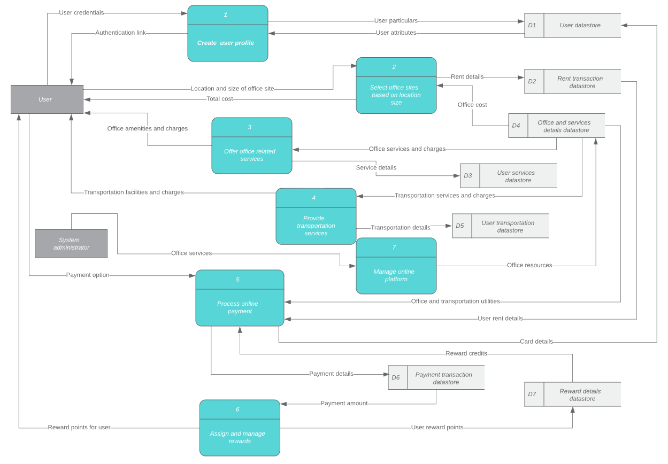

LEVEL 1 - PROCESS 1

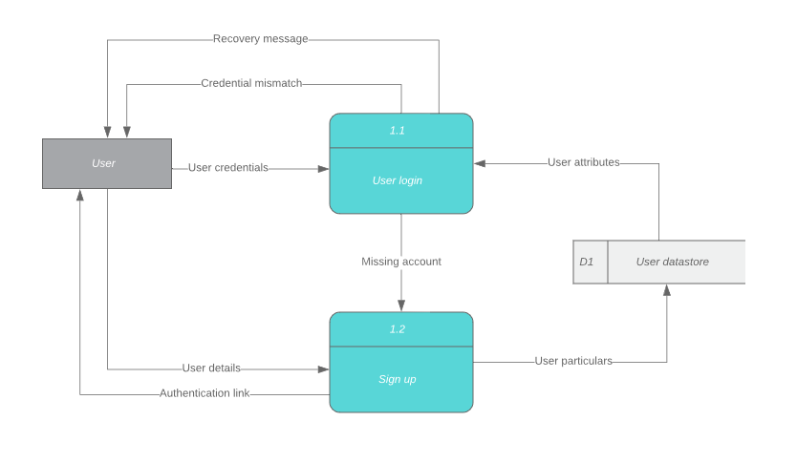

LEVEL 1 - PROCESS 2

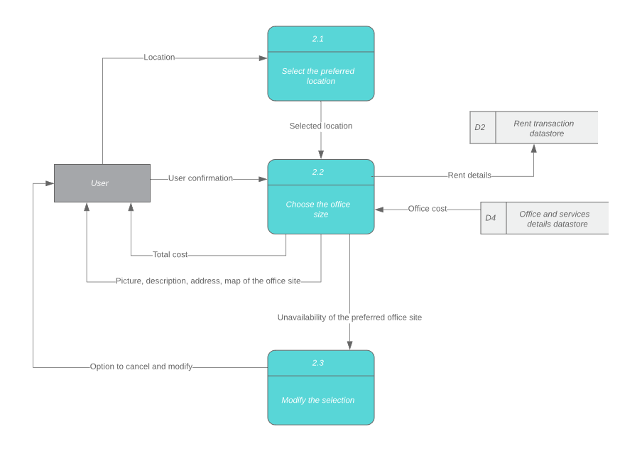

LEVEL 1 - PROCESS 3

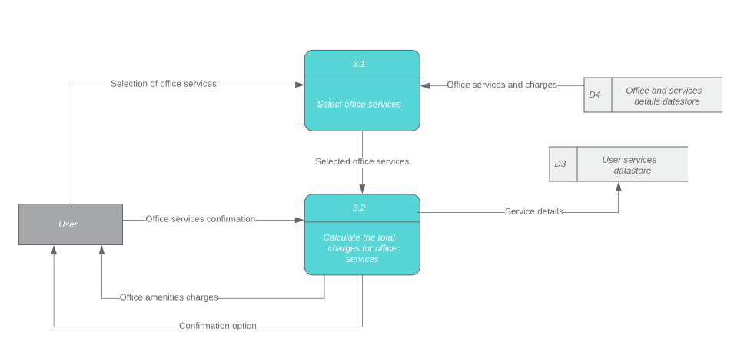

LEVEL 1 - PROCESS 4

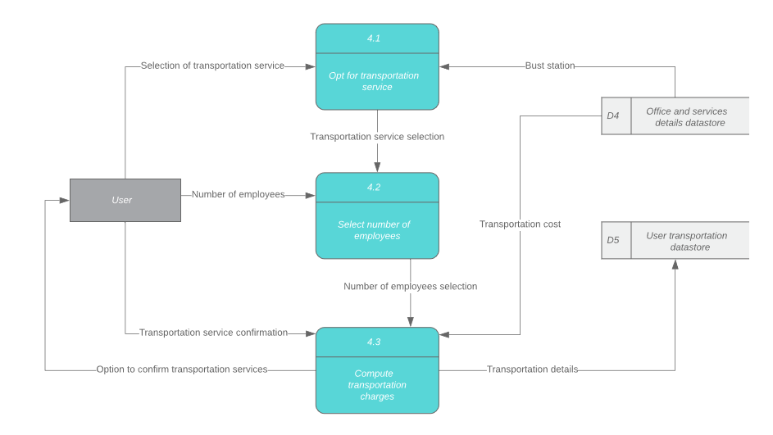

LEVEL 1 -PROCESS 5

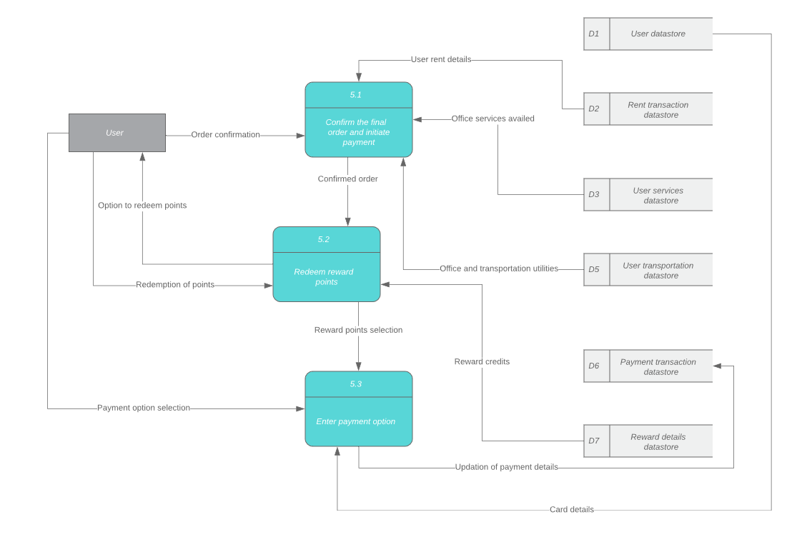

LEVEL 1 - PROCESS 6

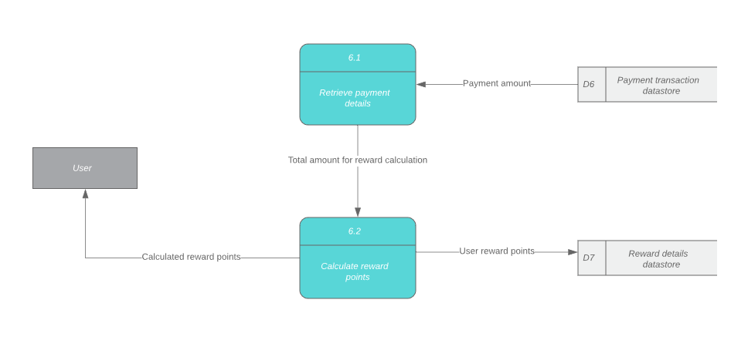

LEVEL 1 - PROCESS 7

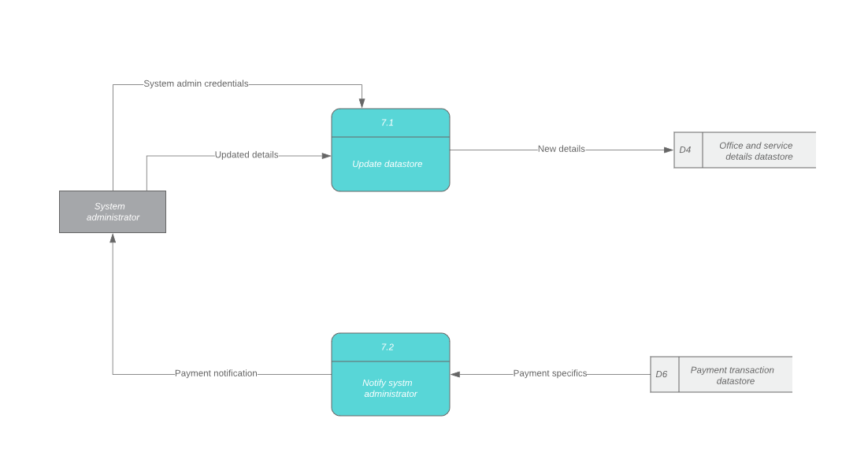

Data Dictionary:

D1: User Database

|  |  |  |  |
| --- | --- | --- | --- |
| **Column_Name** | **Data Type** | **Default Value** | **Description** |
| First_Name | VARCHAR(20) | Null | The user's first name |
| Last_Name | VARCHAR(20) | Null | The user's last name |
| User_ID | VARCHAR(10) | Null | System generates unique User ID once user account is created |
| User_Email | VARCHAR(20) | Null | User's email address |
| User_Pwd | VARCHAR(20) | Null | User's password |
| User_Address | VARCHAR(100) | Null | User's address |
| User_PhoneNumber | Number(10) | 0000000000 | User's phone number |
| User_Zipcode | Number(5) | 00000 | User's area Zipcode |
| User_City | VARCHAR(20) | Null | User’s city |
| User_State | VARCHAR(2) | Null | User's state |

D2: Rent transaction Database

|  |  |  |  |
| --- | --- | --- | --- |
| **Column_Name** | **Data Type** | **Default Value** | **Description** |
| User_ID | VARCHAR(10) | Null | User ID of user |
| Date_Time | DATETIME | Current date | Date and time of conversation |
| Number_of_Desks | INTEGER(5) | 1 | Number of desks selected by the freelancer |
| Number_of_Rooms | INTEGER(5) | 1 | Number of rooms selected by the startup |
| Mode_Of_Reservation | ENUM | Daily | Mode of reservation selected by the user |
| Office_locationID | VARCHAR(10) | Null | Office location ID |

D3: User Services Database

|  |  |  |  |
| --- | --- | --- | --- |
| **Column_Name** | **Data Type** | **Default Value** | **Description** |
| User_ID | VARCHAR(10) | Null | UserID of the user |
| Printer_ID | VARCHAR(10) | Null | PrinterID of the printer availed by the user |
| System_ID | VARCHAR(10) | Null | SystemID of the system availed by the user |
| Confirmation_ID | VARCHAR(10) | Null | Confirmation ID of the user. |
| Internet_service_Availed | VARCHAR(10) | Null | If the user availed the internet services |

D4: Office and services details database

|  |  |  |  |
| --- | --- | --- | --- |
| **Column_Name** | **Data Type** | **Default Value** | **Description** |
| Office_ID | VARCHAR(10) | Null | Unique office ID for each office |
| Service_ID | VARCHAR(10) | Null | Unique service ID |
| TransportService_opt | BOOLEAN(1) | True | Store if the user has opted for transportation services |
| Office_Address | VARCHAR(10) | Null | Address of the office |
| Office_Phone | NUMBER(10) | Null | Phone number of office |
| Available_Room | INTEGER(5) | 00000 | The number of rooms available |
| Room_ID | VARCHAR(10) | Null | ID of room number |
| From_Time | DATETIME | Current date | From time of booking |
| To_Time | DATETIME | Current date | To time of booking |

D5: User transportation database

|  |  |  |  |
| --- | --- | --- | --- |
| **Column_Name** | **Data Type** | **Default Value** | **Description** |
| Transportation_Service_ID | Varchar(10) | Null | ID of the transportation service availed |
| Customer_ID | Varchar(10) | Null | Unique ID of the customer |
| Office_Address | Varchar(30) | Null | Address of the office |
| Station_Address | Varchar(30) | Null | Address of the pick up station. |

D6: Payment transaction database

|  |  |  |  |
| --- | --- | --- | --- |
| **Column_Name** | **Data Type** | **Default Value** | **Description** |
| Payment_ID | VARCHAR(10) | Null | Payment ID of the payment done for a booking |
| User_ID | VARCHAR(10) | Null | User_ID of user |
| Booking_ID | VARCHAR(10) | Null | Booking ID of the parking spot |
| Name_on_Card | VARCHAR(10) | Null | Name on credit/debit card |
| Card_Number | INTEGER(16) | 0000000000000000 | Credit/Debit Card Number |
| Expiration_Date | DATE | Current Date | Expiry Date on card |
| CVV | INTEGER(3) | 000 | Unique ID on card |
| Payment_Status | BOOLEAN(1) | False | Status of payment |

D7: Reward details database

|  |  |  |  |
| --- | --- | --- | --- |
| **Column_Name** | **Data Type** | **Default Value** | **Description** |
| Payment_ID | VARCHAR(10) | Null | Payment ID of the payment done for a booking |
| User_ID | VARCHAR(10) | Null | User_ID of user |
| Points_Earned | INTEGER(6) | 000000 | Points earned after the booking is completed |
| Reservation_ID | VARCHAR(10) | Null | User reservation ID |
| Monthly reward percentage | INTEGER(3) | 000 | Percentage of points for monthly mode of reservation |
| Annual reward percentage | INTEGER(3) | 000 | Percentage of points for annual mode of reservation |

Program Structure Chart:

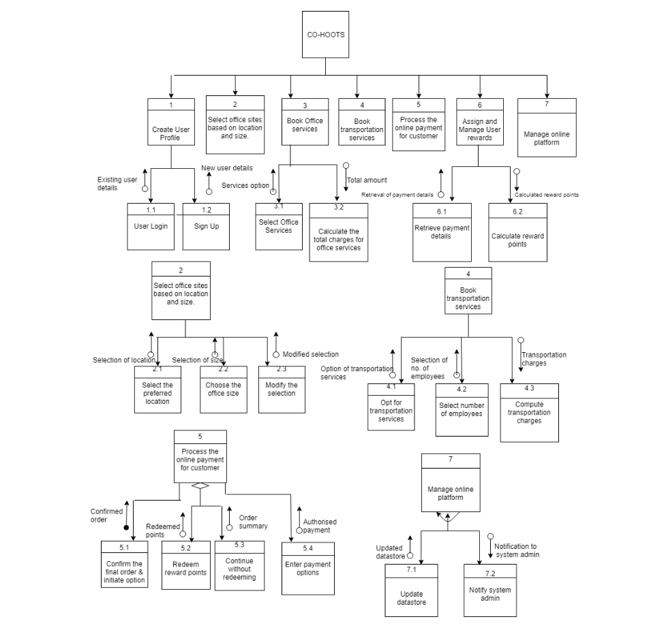

UI Screenshots:

# Future Scope:

Coworking spaces are going to revolutionize and disrupt the way that we know and understand traditional office spaces and environments all across the globe. The future of co-working will include building trusted community of like-minded peers, partners, and supporters to exchange thoughts and collaborate on projects within creative spaces designed to accelerate learning. Co-working spaces will introduce great thought leaders, connect entrepreneurs with new collaborators, all in service of creating solutions-focused businesses and building a better world we know is possible.

# Conclusion:

The Co working space system will allow the freelancers and startups to rent the office sites as per their needs and convenience. We are also providing users with the office services and transportation services to provide the user with seamless working and easier commute to the offices. The user reward points can also be used to get discount on future orders.

References:

1. <https://www.futureofeverything.io/future-coworking-spaces/>